- CASE and TRAYS TRACKING PROCESS:

- Bring In Case Cart
- Open Censitrac App
- Log In
- Go to Menu
- Choose “Workflow”
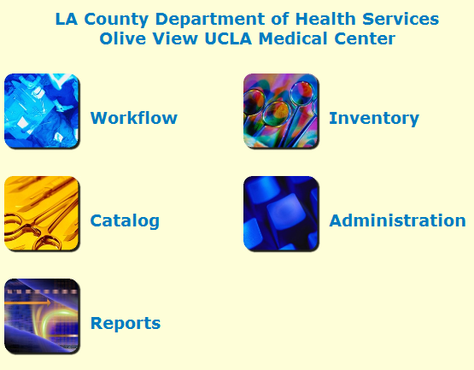
6. Go to Case Tracking
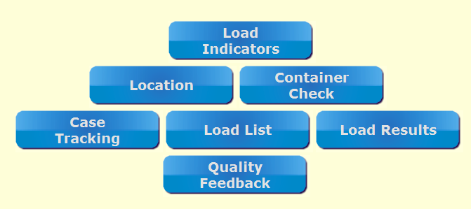
7. Type Case Tracking ID: Enter Case # such as “OVMOR2019-****”
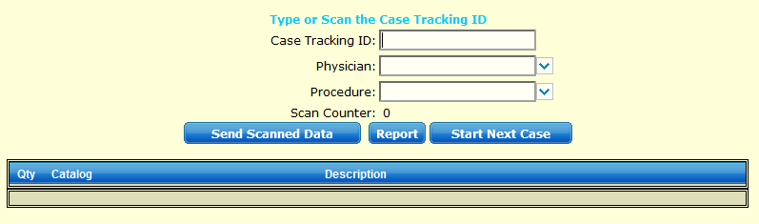

- Scan Barcodes:
  - Room
  - Case Cart
  - Trays
- Click “Send Scanned Data” to Save
- Log off when completed
- Repeat process for next case
B. MISSING or DAMAGED INSTRUMENT(S) FROM TRAY:
  - Repeat Step 1-5 (from Case and Trays Tracking)
  - Go to “Quality Feedback”

  - Enter Case Reference
  - Scan Tray’s Barcode under “Asset Name”
  - Select Quality Event from drop down menu
  - Enter “Responsible Party” – enter “SPD” or responsible “SPD staff’s name”
    - Refer to Staff’s Name on Tray’s Censitrac Tag
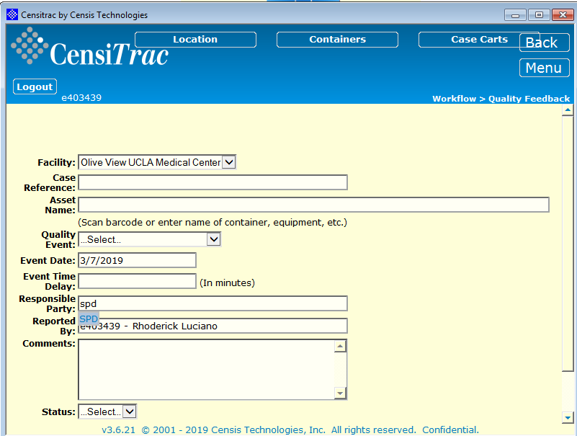
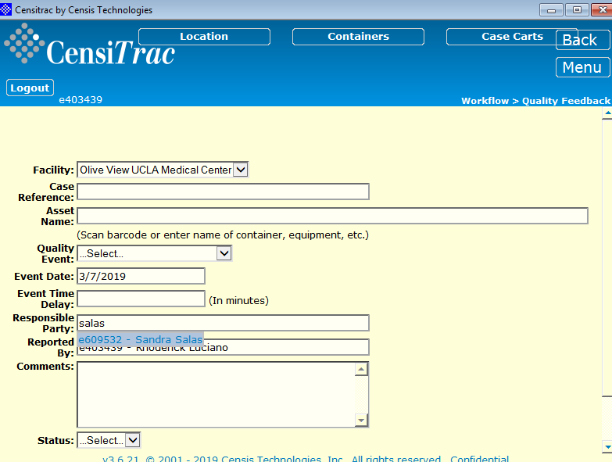

  - Enter “Comments:” Ex: missing Debakey Forcep, Please advise or Scissors Needs Sharpening, etc.
  - Choose “Status” as Open
  - Click Save

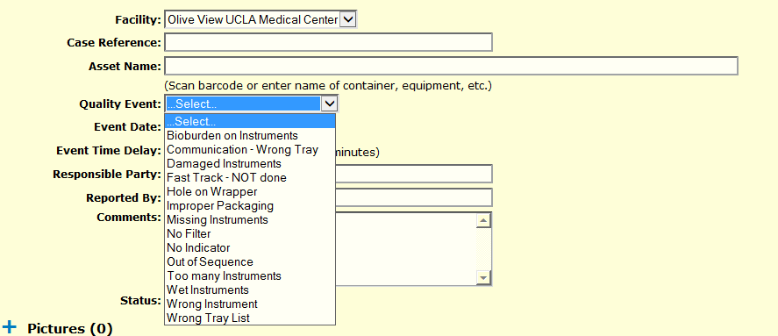

C. LOCATION OF TRAYS or PEELPACKS
- Repeat Steps 1-5 (from Case and Trays Tracking)
- Go to “Inventory”

- Go to “Containers”

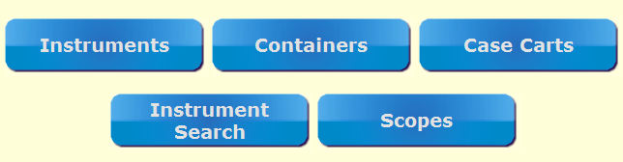

- Search: Enter Name of Instrument (Peel Pack) or Tray, click on correct entry and press enter, e.g. “ Major…Enter”

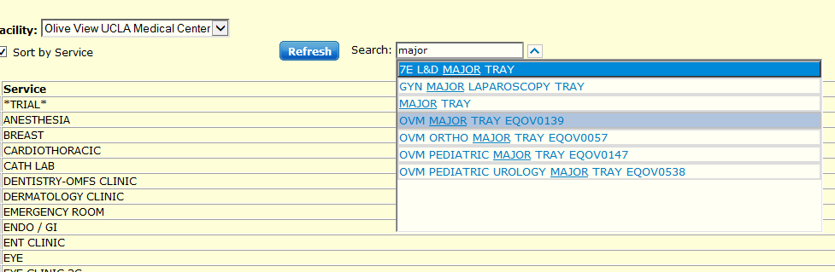

Important Notes:
- Type “Short Name” of Tray instead of full name
- Choose only trays with prefix of “OVM……” (Example: OVM Major Tray EQOV0139)

- When entered, will show “Status, Location, Case Cart, Quantity...”
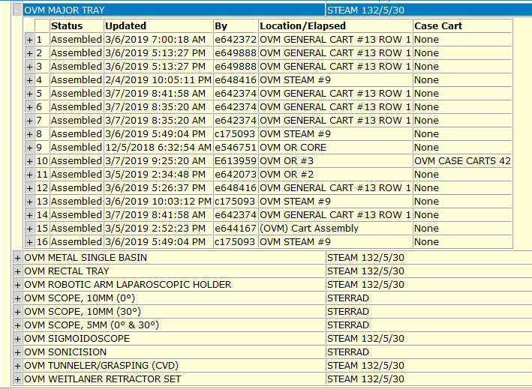

- COUNTSHEET Printout

- Under Process “C” (Location of Trays/PeelPack)
- Look Up for Tray, e.g. Major Tray
- Choose and Click on “Standard Count Sheet”

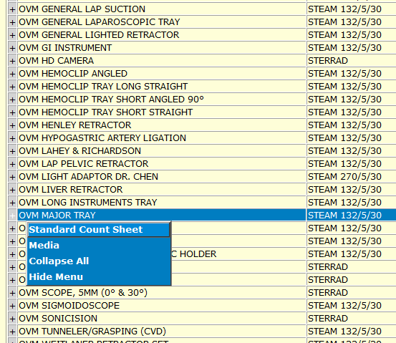

- Printout

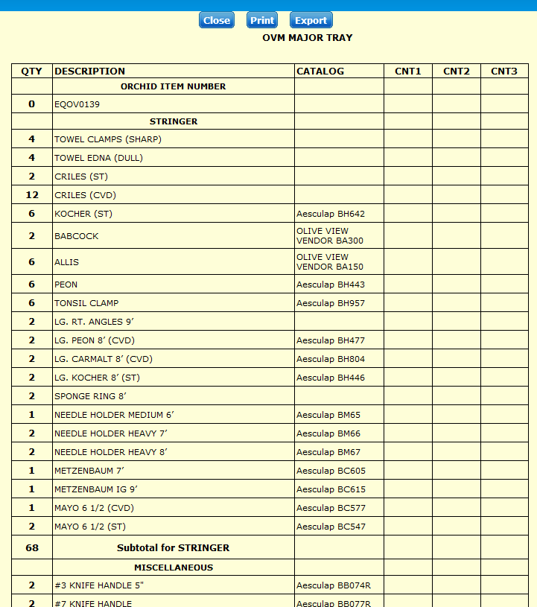

- Please Note Count Sheet Printout will not be reflective of tray’s actual accurate count sheet processed by Sterile Processing Department (SPD) during assembly.

- TRAY MISSING FROM CASE CART
  - If tray is missing, pull from another case cart, scan and add tray under process “A.”

- UNUSED TRAY(S) FROM CASE CART
  - Return to S.P.D.

Information provided with assistance from Harbor-UCLA Medical Center Staff:
- Dana, OR Nursing Supervisor
- Brenda Pestano, RN
- Nelsy Hernandez, CST
- Haemin “Jenny” Lee, RN
- Erin Ibarra, RN
- Andrea Parungo, RN

